Module 1:
1. Singleton pattern
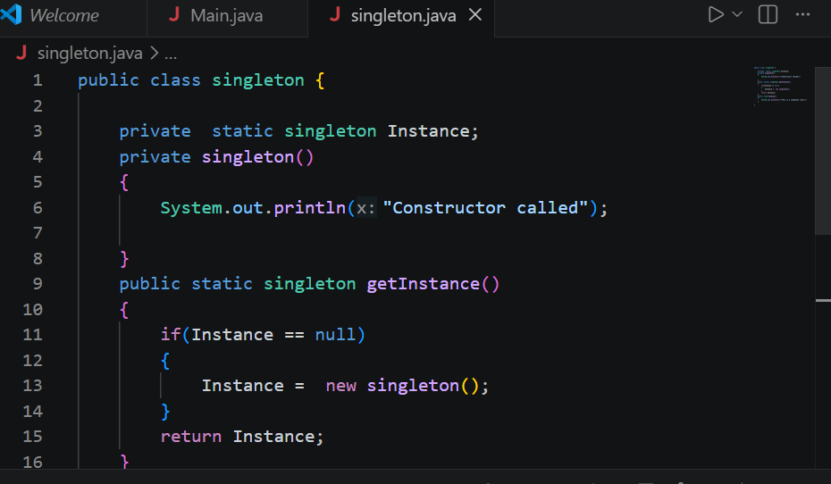
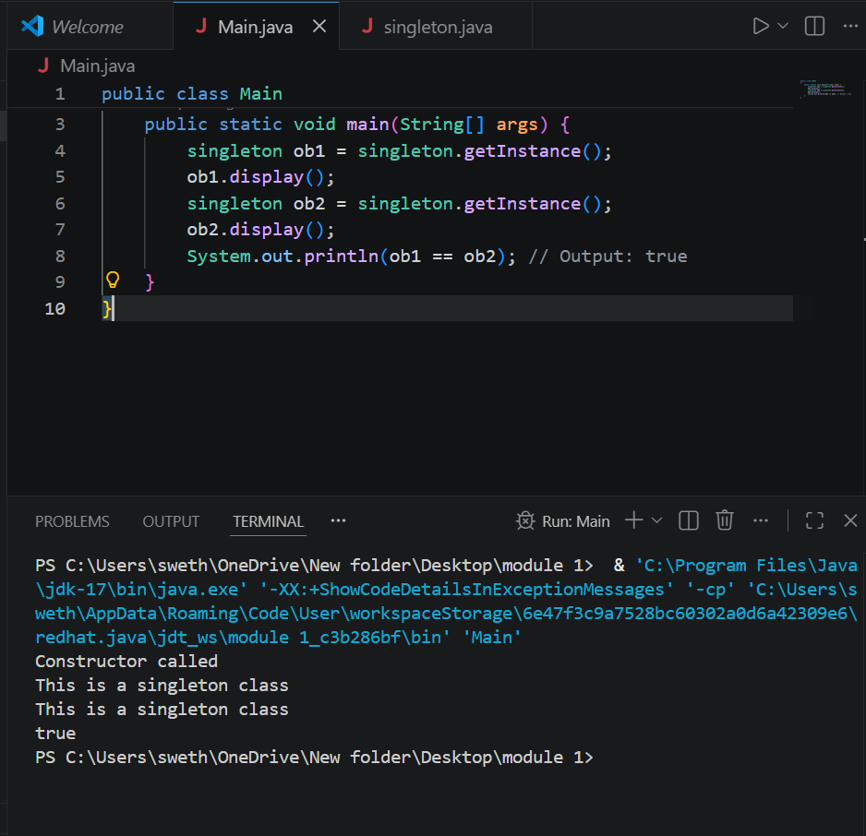

2. Implementing Factory method pattern
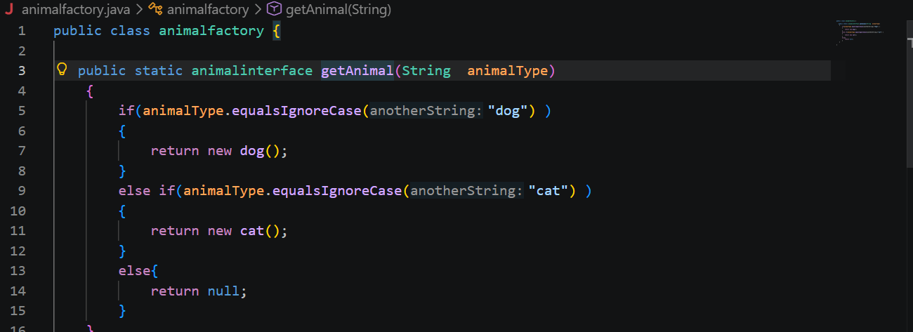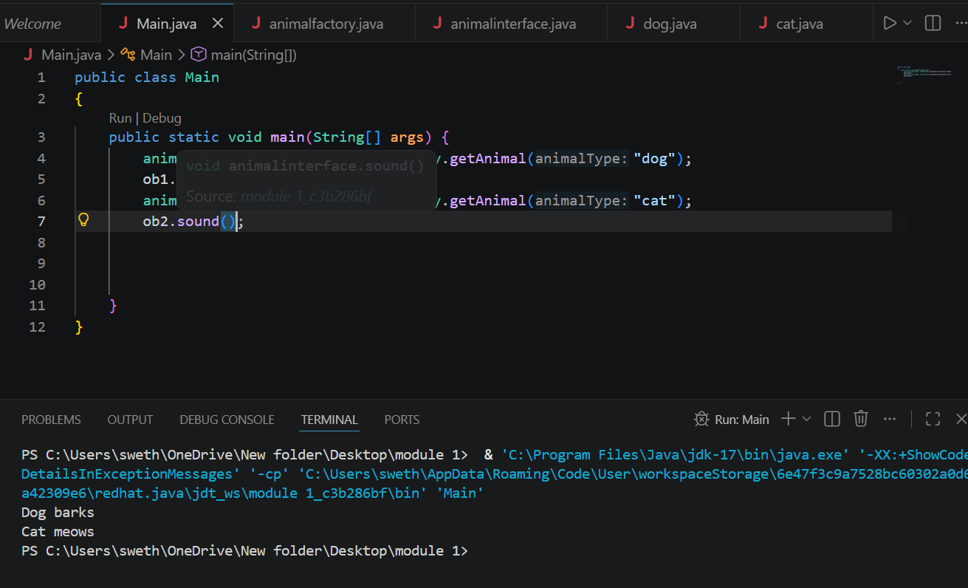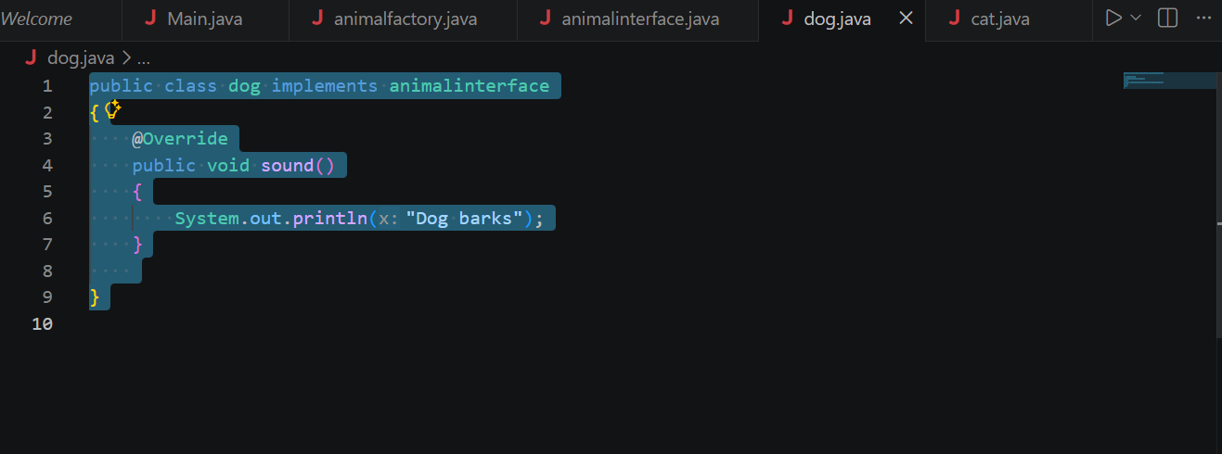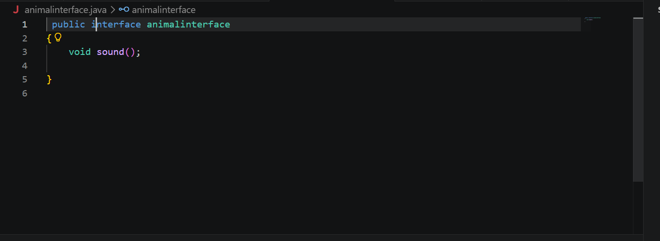
3. E-commerce using data structures
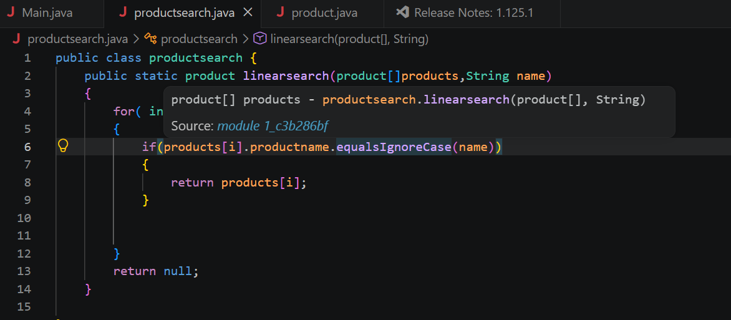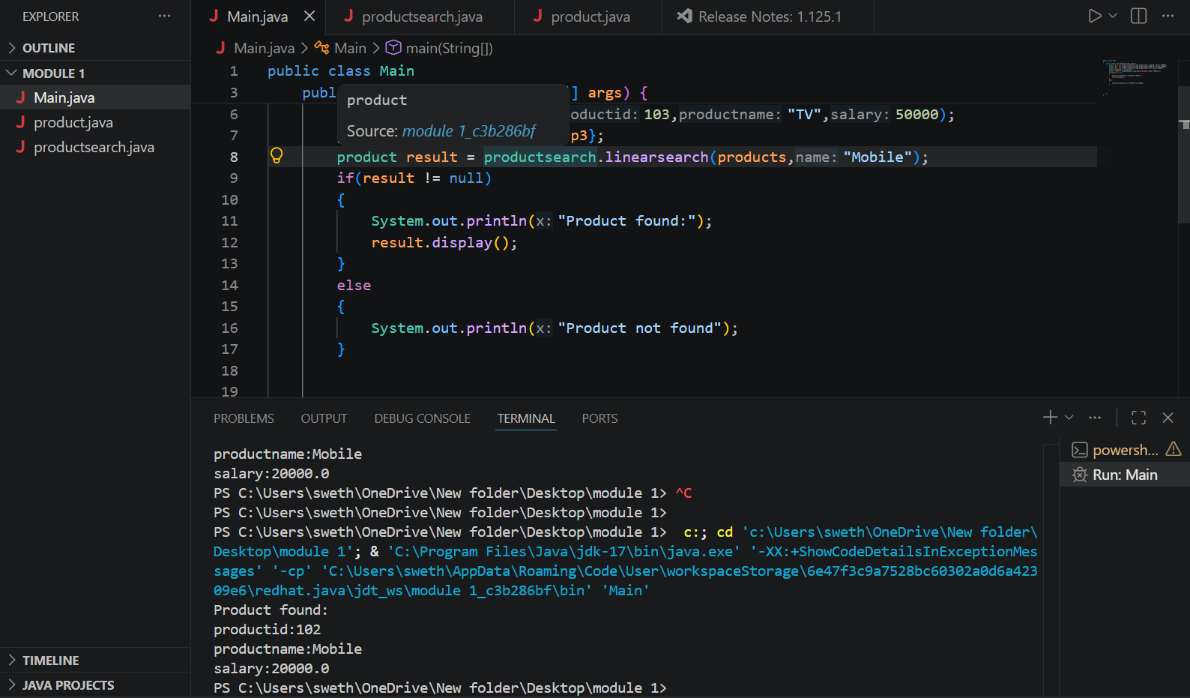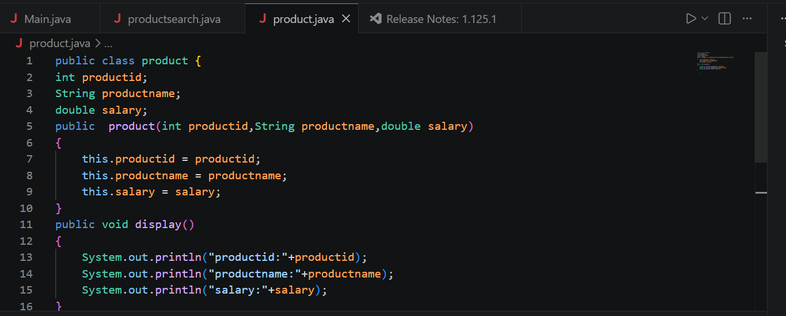
4.Financial forecasting(recursion)
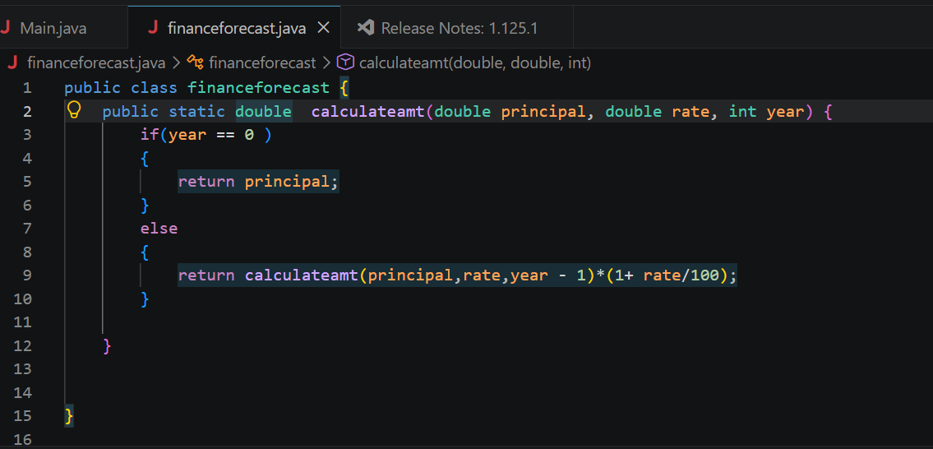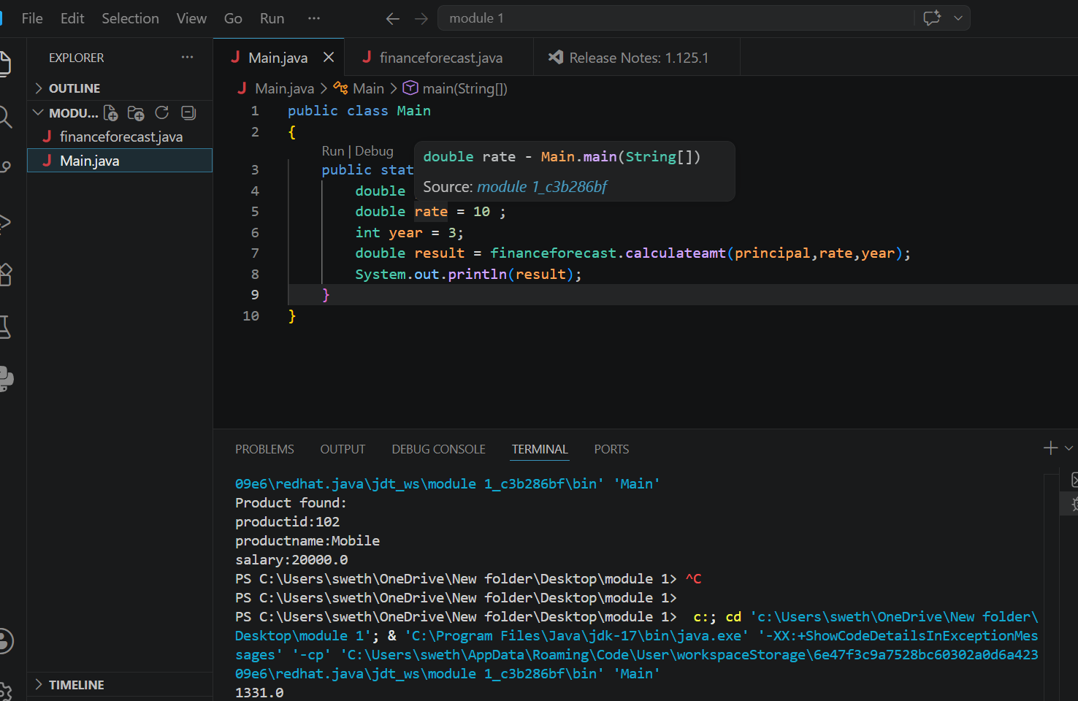
5.PL/SQL PROGRAMMING (control structures)
SELECTION
ITERATION
SEQUENTIAL
SELECTION:
IF EXMAPLE
DECLARE
num NUMBER := 30;
BEGIN
IF(num > 5) THEN
DBMS_OUTPUT.PUT_LINE(‘PASS’);
END IF;
END;

IF – ELSE
DECLARE
num NUMBER := 30;
BEGIN
IF(num > 5) THEN
DBMS_OUTPUT.PUT_LINE(‘PASS’);
ELSE
DBMS_OUTPUT.PUT_LINE(‘FAIL’);
END IF;
END;
IF..ELSIF…ELSE
DECLARE
num NUMBER := 30;
BEGIN
IF(num <30 ) THEN
DBMS_OUTPUT.PUT_LINE(‘n I ssmaller’);
ELSIF(num =30)
DBMS_OUTPUT.PUT_LINE(‘equal’);
ELSE
DBMS_OUTPUT.PUT_LINE(‘N is greater’);
END IF;
END;
CASE STATEMENTS
DECLARE
dayno NUMBER := 2;
BEGIN

CASE dayno
WHEN 1 THEN
DBMS_OUTPUT.PUT_LINE('Monday');

WHEN 2 THEN
DBMS_OUTPUT.PUT_LINE('Tuesday');

WHEN 3 THEN
DBMS_OUTPUT.PUT_LINE('Wednesday');

ELSE
DBMS_OUTPUT.PUT_LINE('Invalid Day');

END CASE;

END;
ITERATION
DECLARE
i NUMBER := 1;
BEGIN

LOOP

DBMS_OUTPUT.PUT_LINE(i);

i := i + 1;

EXIT WHEN i > 5;

END LOOP;

END;
WHILE
DECLARE
i NUMBER := 1;
BEGIN

WHILE i <= 5 LOOP

DBMS_OUTPUT.PUT_LINE(i);

i := i + 1;

END LOOP;

END;
FOR LOOP
BEGIN

FOR i IN 1..5 LOOP

DBMS_OUTPUT.PUT_LINE(i);

END LOOP;

END;
Nested I f
DECLARE
num NUMBER := 12;
BEGIN

IF num > 0 THEN

IF num MOD 2 = 0 THEN
DBMS_OUTPUT.PUT_LINE('Positive Even Number');
END IF;

END IF;

END;
NESTED LOOP
DECLARE
FOR i in 1..3 LOOP
FOR j in 1..3 LOOP
DBMS_OUTPUT.PUT_LINE(‘i=’||i||’j=’||j)
END LOOP;
END LOOP;
END;
PL/SQL PROCEDURES
CREATE PROCEDURE GetStudentDetails (
p_StudentID IN NUMBER
)
IS
v_FirstName Students.FirstName%TYPE;
v_LastName Students.LastName%TYPE;
v_BirthDate Students.BirthDate%TYPE;
v_City Students.City%TYPE;
v_Country Students.Country%TYPE;
BEGIN
SELECT FirstName, LastName, BirthDate, City, Country
INTO v_FirstName, v_LastName, v_BirthDate, v_City, v_Country
FROM Students
WHERE StudentID = p_StudentID;
DBMS_OUTPUT.PUT_LINE(v_FirstName || ' ' || v_LastName);
END;
6. Setting up in POM.XML
<dependency>
<groupId>org.junit.jupiter</groupId>
<artifactId>junit-jupiter</artifactId>
<version>5.10.2</version>
<scope>test</scope>
</dependency>
7. Assertion in JUNIT
import static org.junit.jupiter.api.Assertions.assertEquals;

import org.junit.jupiter.api.Test;
public class test
{
@Test
void test add()
{
int a = 5 ;
int b = 10;

int result = a+ b;
assertEquals(15,result);
assertNotEquals(40,result);

}
@Test
void testTrue() {

int age = 20;

assertTrue(age >= 18);

}
@Test
void testFalse() {

int age = 15;

assertFalse(age >= 18);

}
@Test
void testNull() {

String name = null;

assertNull(name);

}
@Test
void testNotNull() {

String name = ‘ram’;

assertNull(name);
@Test
void testException() {

assertThrows(ArithmeticException.class, () -> {

int result = 10 / 0;

});

}

}

}
7. AAA PATEERN – ARRANGE ACT ASSERT
ARRANGE
Calculator calculator = new Calculator();

int a = 10;
int b = 20;
ACT
int result = calculator.add(a, b);
ASSERT
assertEquals(30, result);
FULL CODE
CALCULATOR.java
public class Calculator {

public int add(int a, int b) {
return a + b;
}

}
CALCULATORTEST.java
import org.junit.jupiter.api.Test;

import static org.junit.jupiter.api.Assertions.*;

public class CalculatorTest {

@Test
void testAddition() {

( Arrange)
Calculator calculator = new Calculator();
int a = 10;
int b = 20;

( Act)
int result = calculator.add(a, b);

( Assert)
assertEquals(30, result);
}

}
8. Test fixtures
import org.junit.jupiter.api.*;

import static org.junit.jupiter.api.Assertions.*;

public class CalculatorTest {

Calculator calculator;

@BeforeEach
void setup() {

calculator = new Calculator();

System.out.println("Calculator Created");

}

@Test
void testAdd() {

assertEquals(30, calculator.add(10,20));

}

@Test
void testSubtract() {

assertEquals(5, calculator.subtract(10,5));

}

}
9. Setup and teardown methods in JUNIT
import static org.junit.jupiter.api.Assertions.assertEquals;

import org.junit.jupiter.api.AfterAll;
import org.junit.jupiter.api.AfterEach;
import org.junit.jupiter.api.BeforeAll;
import org.junit.jupiter.api.BeforeEach;
import org.junit.jupiter.api.Test;

public class CalculatorTest {

Calculator calculator;

@BeforeAll
static void beforeAllMethod() {
System.out.println("Application Started");
}

@BeforeEach
void setup() {
System.out.println("Creating Calculator Object");
calculator = new Calculator();
}

@Test
void testAddition() {

int result = calculator.add(10, 20);

assertEquals(30, result);

System.out.println("Addition Test Passed");
}

@Test
void testSubtraction() {

int result = calculator.subtract(20, 5);

assertEquals(15, result);

System.out.println("Subtraction Test Passed");
}
@AfterEach
void tearDown() {
System.out.println("Cleaning Resources");

@AfterAll
static void afterAllMethod() {
System.out.println("Application Closed");
}
}
9.MOCKING , STUBBING AND VERIFICATION
paymentservice.java
public class PaymentService {

public boolean makePayment(int amount) {

System.out.println("Real Payment Done");

return true;
}

}
orderservice.java
public class OrderService {

private PaymentService paymentService;

public OrderService(PaymentService paymentService) {

this.paymentService = paymentService;

}

public String placeOrder(int amount) {

if (paymentService.makePayment(amount)) {

return "Order Placed Successfully";

}

return "Payment Failed";

}

}

Orderservicetest.java
import static org.junit.jupiter.api.Assertions.assertEquals;
import static org.mockito.Mockito.*;

import org.junit.jupiter.api.Test;

public class OrderServiceTest {

@Test
void testPlaceOrder() {

// Step 1 : Create Mock Object
PaymentService paymentService = mock(PaymentService.class);

// Step 2 : Stub the Mock
when(paymentService.makePayment(1000)).thenReturn(true);

// Step 3 : Inject Mock into OrderService
OrderService orderService = new OrderService(paymentService);

// Step 4 : Call the Method
String result = orderService.placeOrder(1000);

// Step 5 : Assertion
assertEquals("Order Placed Successfully", result);

// Step 6 : Verification
verify(paymentService).makePayment(1000);

}

}
10. Slf4 error messages and warning levels
INFO LEVE;
LOGGER.INFO(‘’);
import lombok.extern.slf4j.Slf4j;

@Slf4j
public class InfoExample {

public static void main(String[] args) {

log.info("Application Started");

String username = "SWATHI";

log.info("User {} logged in successfully", username);

log.info("Application Closed");
}
}
DEBUG LEVEL
import lombok.extern.slf4j.Slf4j;

@Slf4j
public class DebugExample {

public static void main(String[] args) {

int marks = 95;

log.debug("Marks = {}", marks);

String subject = "Java";

log.debug("Subject = {}", subject);
}
}
WARN LEVEL
import lombok.extern.slf4j.Slf4j;

@Slf4j
public class WarnExample {

public static void main(String[] args) {

int storage = 5;

if(storage < 10) {
log.warn("Disk space is low. Remaining: {} GB", storage);
}

log.info("Application is still running");
}
}
ERROR LEVEL
import lombok.extern.slf4j.Slf4j;

@Slf4j
public class ErrorExample {

public static void main(String[] args) {

try {

int result = 10 / 0;

}

catch(Exception e) {

log.error("Exception occurred", e);

}

}

}

